

Total Coliforms in 10h for drinking water
(ISO 9308-01 based)
Stop waiting 48 hours. MICA Advance Total Coliforms delivers culture-based enumeration of Total Coliforms after just 10 hours of incubation.

  10h Time-to-Result
  Release batches earlier.
  Standard CCA agar & membranes
  No additional consumables.
  High throughput
  Up to 500 analyses / shift.
  Automatic counting
  in CFU/filtered volume

Maximize your Lab's ROI
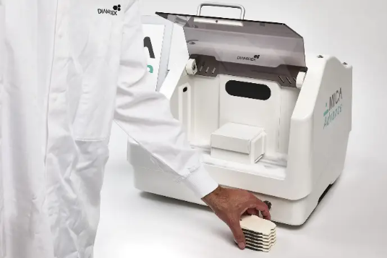
One MICA Advance counter covers all your critical indicators. The equipment you use for Total Coliforms is also compatible with:
  ✓ | Legionella pneumophila  48h results
  ✓ | Alicyclobacillus  24h results
  ✓ | E. coli  6h results
  ➞ | Pseudomonas aeruginosa  Coming Soon

